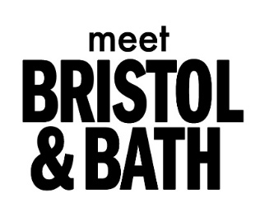
53 Queen Square I Bristol I BS1 4LH I
Convention Bureau Contact: amy.phillips@meetbristolbath.co.uk
Media Contact: emma.frayling@visitwest.co.uk

MEET BRISTOL & BATH FINALISTS FOR TWO INDUSTRY AWARDS

FOR IMMEDIATE RELEASE
The Meet Bristol & Bath Convention Bureau team have been named finalists for two prestigious event industry awards.
The team have been shortlisted for ‘Best UK Convention Bureau’ at the M&IT Awards, the event industry’s biggest awards programme. Fellow finalists include convention bureaus representing Belfast, Birmingham and the West Midlands, Glasgow, Liverpool and London. The winners of the award will be announced at the awards event at Evolution London on the 8th October 2021.
The team have also secured a place as finalists for the ‘miaList 2021 Team Award’, which recognises outstanding and passionate teams from across the meetings, hospitality and events industry.
Meet Bristol & Bath is nominated in the Best Destination category, along with Convention Bureau teams from Belfast, Leeds and Liverpool. The winner will be announced at an awards ceremony at the Millennium Gloucester Hotel on the 4th November 2021.
The team’s place on the shortlists follows their rebrand at the beginning of the year to become a regional convention bureau, offering services in Bristol, Bath and the surrounding areas.
‘This is an incredible, but well deserved, double shortlist for the Meet Bristol & Bath team. The last 18 months have been catastrophic for the events industry, and the team, which at time was reduced to just one person due to furlough, continued to support organisers and venues whether rescheduling or providing updates and guidance. I am so proud of all they have achieved, not least the rebrand and inclusion of venues in the Bath area, extending their service to cover the west of England. Their dedication and positivity in incredibly difficult circumstances has been inspiring’. Kathryn Davis, Director of Tourism, Visit West
ENDS
For further information:
Website: meetbristolbath.co.uk

Bristol and Bath is one of the strongest economies in Europe and is home to globally recognised industry clusters. Key economic strengths are in Advanced Engineering & Aerospace, High-Tech, Digital & Creative, Energy, Life Sciences and Professional Services. These are supported by major global players, creative start up’s and four leading Universities between the two cities. Neighbouring cities, Bristol and Bath are just 10 minutes apart by train and their complementary natures make them ideal destinations for conferences, events and incentive travel. Business events were worth an estimated £347m to Bristol and the surrounding areas in 2019, with social events accounting for an additional £26.1m (Bristol Conference and Meetings Survey2020).

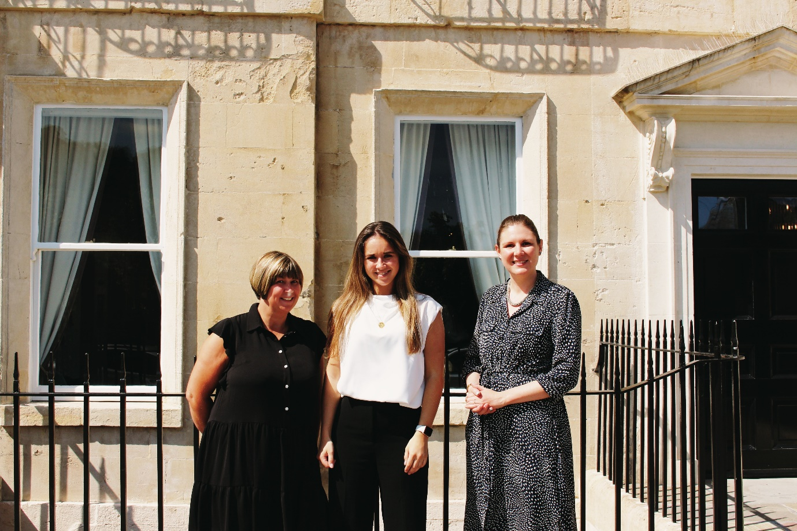
The Meet Bristol & Bath Team (left to right) – Vicki Webb, Anna Mead, Amy Phillips

